IDENTIFICATION AND MAPPING OF POTENTIAL GROUND WATER CONTAMINATION SOURCES IN URBAN TECATE
Katherine Comer, San Diego State University
Key Words: GIS, PCA inventory, wellhead protection, aquifer, point sources, interdisciplinary, data integration
Introduction
Water resources in the Tecate region are under threat (Castro Ruiz 2002; Holsher 2005; Forster 2005). Wells are being contaminated, and half the wells operated by the State Water Commission of Tecate (CESPTE) are dry, forcing Tecate to increase its imported water from 20% of total usage in 1999, to 90% of the total usage in 2005 (CESPTE data unpublished). Urban streams rarely flow, and testing indicates high pollution levels (Lozano 1995; Gersberg et al. 2000; Luderitz et al. 2005; Rodríguez and Wakida 2005; CESPTE data unpubl.). However, Tecate still is able to use ground water to meet around 10% of its demand. Proper planning and protection of the aquifer and wellheads could stabilize the downward trend for Tecate’s ground water quality and quantity.
This interdisciplinary one-year field project involved a team of researchers from San Diego State University and the Autonomous University of Baja California. The goal of the project was to create a data storage and analysis tool for ground water and surface water resources in Tecate, Baja California, Mexico. The project converted existing spatial and non-spatial data into a high-resolution Geographic Information System (GIS), for ease of use by agencies, researchers, and the public. We trained the client, the State Commission for Public Services in Tecate (CESTPE), on the use of the GIS, and the client also has access to tabular data in a non-GIS format. The client will use the database to plan for future water services in the community and for improving wellhead protection and monitoring programs.
The project also inventoried potential sources of ground water and surface water contamination in Tecate using the California’s Department of Health Services Possible Contaminating Activities (PCA) Inventory for Ground Water (CADWSAP 2003). However, the PCA categories and risk levels were not totally appropriate for Tecate, Mexico. Therefore, we modified the checklist according to suggestions from the Helperin et al. (2001) and local CESPTE experts to more accurately describe the potential level of contamination to the groundwater in Tecate. This exercise was also useful in determining if a binational checklist could be created that might aid managers implementing binational pollution prevention programs. We collected GPS locations of PCAs in the field and subjectively rated their risk to groundwater resources utilizing California’s PCA risk classes combined with expert opinion from CESPTE personnel.
The project’s products are packaged in a GIS project which includes the following layers, all of which are accompanied by bilingual metadata found on http://trw.sdsu.edu/English/GIS/InterMaps/ims/website/tecateGWpublic/viewer.htm:
- An aerial photograph flown by NOAA in 2000 at a scale of 1:24,000. The series was mosiaced using ERDAS Imagine software by Dave McKenzy from the CESAR Lab at SDSU in 2004. Other layers were digitized against this high resolution base layer.
- A land use map of the year 2000 at a scale of 1:24,000 was created, that borrows from existing Autocad layers of land use from previous years provided by the Municipality of Tecate. The landuse classes were reassigned according to land use classes from the "San Diego-Tijuana Border Area Planning Atlas" published by IRSC-SDSU in 2002. This present shapefile contains an additional class "agriculture" which includes olive groves and ranches and omits the class "open water" which is represented in the study area (the river is a separate shapefile). The class "green areas" includes parks, plazas, sport courts, undeveloped or vacant land, and plant nurseries. The "industrial" class includes maquilas, industrial operations, and truck yards. "Public Facilities and utilities" includes schools (but not the sport fields), hospitals, churches, and infrastructure facilities. Residential densities were based on expert opinion from the DAU and the Municipality of Tecate for the year 2000. The "commercial" class includes any business, from spas to car junkyards. "Cattle lot" received its own class because of its high potential for contamination to the aquifer. The polygons and landuse classes were verified in the field and by agencies in the Departamento de Administración Urbano of the Municipality of Tecate and CESPTE personnel circa the year 2000.
- Point data on 141 wells in the study area are linked to tabular well data that was provided by Mexico’s National Water Commission (CNA), CESPTE, Tecate’s largest industry—the Tecate Brewery, and the University of Utah research (Forster 2005; Holsher 2005). These include private, public, and norias (hand dug wells). The tabular data contain data on the physical characteristics and uses of the wells, along with a time series of monthly pumping rates. The wells and norias were not all in operation nor are they continually monitored at the time of the project (2004). Future data may be added to the database in excel and linked to the GIS.
- Within the 200-meter buffer zone on either side of the river, possible contaminating activities (PCAs) to groundwater were mapped with GPS and ranked with CESPTE expert opinion according to their threat: very high, high, medium, and low.
- We used the GIS to create concentric rings around each well delineating the area where PCAs might be able to travel through the substrate to a wellhead in approximately two years. The default distance used was 187 meters for a two year travel time assuming a porous aquifer and 274 meters assuming a fractured rock aquifer. The rings are by default circular, although this may not reflect the true nature of the zone of risk.
- We digitized the estimated extent of the Tecate porous sand aquifer in 2004 as described by hydrogeologist Dr. Craig Forster, University of Utah, who worked in Tecate in 2004 (Forster 2005). This was buffered by 200 meters in the GIS.
- We digitized the estimated maximum extent of the granite bedrock aquifer as estimated by researchers at the University of Utah (2004). This extent is the 600 m.a.s.l. contour line, within which bedrock can be seen above ground. This boundary represents an extent where CESPTE might look for new wells locations in the bedrock fractures.
- We digitized the neighborhoods not serviced by sewage connection in 2004 as described by personnel at CESPTE.
- We digitized the Tecate River in 2000.
- We also included previously collected GIS shapefiles on vegetation (SDSU 1994),
- Soils (provided by Cal Poly Tech 2002 Pomona),
- The Tecate River (SDSU 1994),
- Streams (SDSU 1994),
- Roads (SDSU 1994),
- Railroads (SDSU 1994),
- The international border (SDSU 1994).
All shapefiles were provided to CESPTE and the Municipal Department of Urban Administration (DAU), and are also available at http://trw.sdsu.edu/English/GIS/GISDownloads/tecateDataDownloads.htm. An online version of the project was published using ESRI’s ArcIMS 9.0 available at http://trw.sdsu.edu/English/GIS/InterMaps/ims/website/tecateGWpublic/viewer.htm. With this tool users can display data, query the attribute tables, and design basic maps. Binlingual metadata webpages accompany each layer.
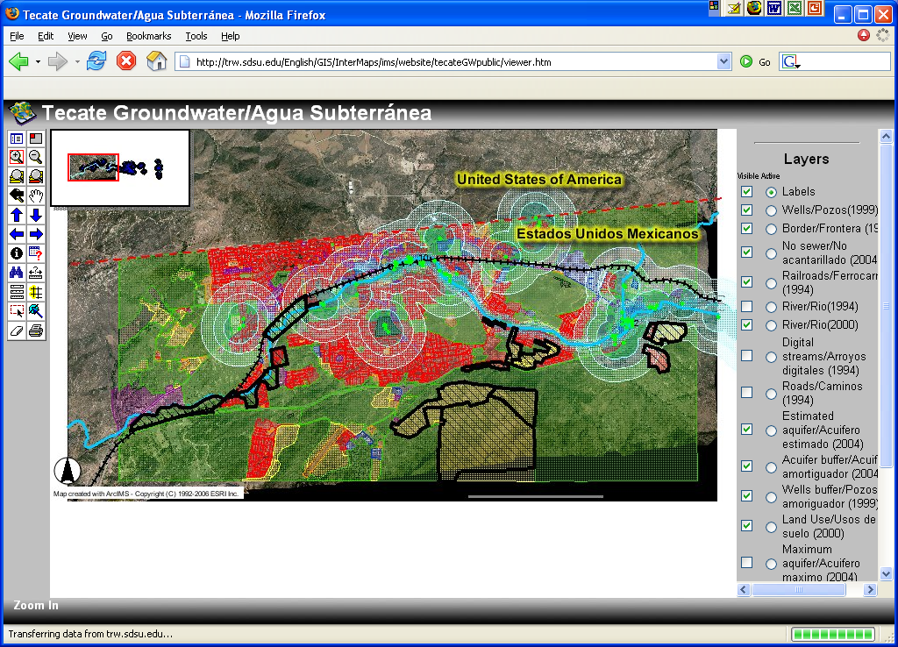
Using the GIS database, the research team came to the following basic conclusions about Tecate’s groundwater. These issues deserve further investigation by Mexican authorities and well owners.
- 13 PCAs of very high and high risk occur over or within 200 meters of the aquifer
- 41 wells are at risk of contamination by very high and high risk PCAs. If one of these PCAs should emit contamination, it would take approximately two years to reach the wellhead (187 m buffer assuming a porous sandy aquifer). Most of these are CESPTE wells used for potable water and were active in 1999.
- The following is the breakdown of land use percentage for the areas above the aquifer and its buffer
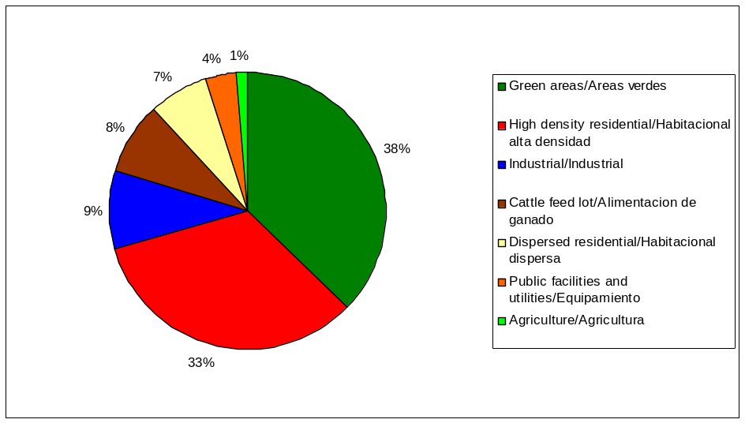

- The following is the breakdown of land use percentage for the areas near the wells (assuming a two-year travel time through a porous aquifer we used 184 meter spheres)
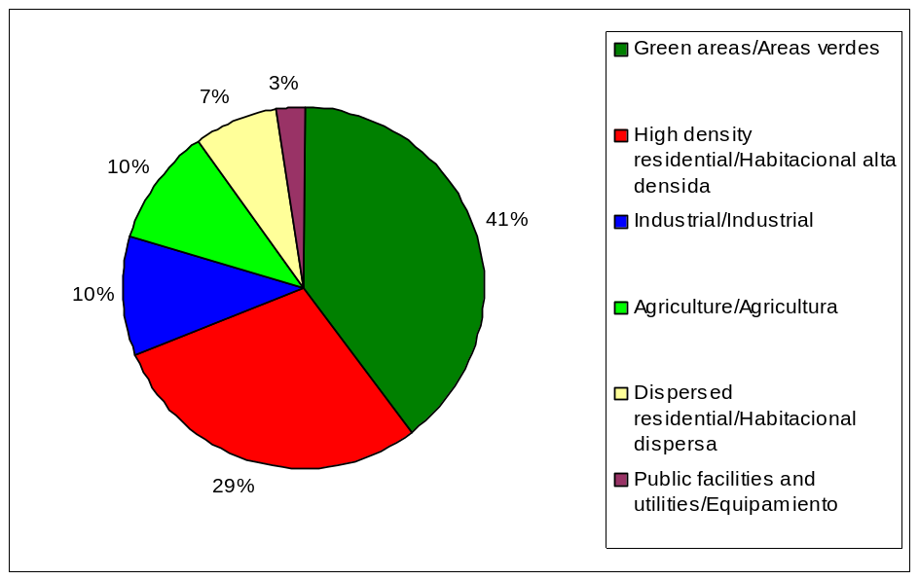

Recommendations
- Future land use zoning should protect the eastern well heads that are not surrounded by urban development.
- Improve the well monitoring program and start an aquifer monitoring program to obtain conclusive results on groundwater quality.
- Collaborate with the Mexican Federal Attorney General for Environmental Protection (PROFEPA) on future PCA surveys. The combination of an outside academic, an authority, and the local surveyor with local knowledge would all value to the results and increase the likelihood of action on the part of the government.
- Collaborate with Mexico on a cost-benefit analysis of a comprehensive conversion of Autocad files to GIS along the U.S.-Mexico border.
Future research questions
This project’s goal was to provide the client with a water resources data clearinghouse and analysis tool, not to perform the analysis. Some questions that the client could investigate using this GIS package are:
- Are there spatial or temporal trends in the decline of ground water levels?
- Are there gaps in water quality testing spatially or temporally?
- Are there spatial and temporal trends in groundwater quantity, or well levels?
- Is there a correlation between trends in groundwater levels and groundwater quality?
- Which wells should be protected first based on depth, risk of contamination, water quality, pumping rates, and water levels?
- How much land area runs off into each well head, and what are the land use classes?
- Which wells are most at risk from non-point sources such as storm water runoff?
- Where are CESPTE’s most promising sources of clean well water, and how can land use zoning be changed to protect those wells from contamination?
- How would Baja California well head protection programs compare to California’s programs, and could a binational solution be implemented? For example, California’s leading causes of groundwater contamination are (Helperin 2001):
    - leaking underground storage tanks,
    - natural sources,
    - agriculture,
    - land fills,
    - septic seepage,
    - and industrial point sources.
Discussion
Some researchers may be interested in the “lessons learned” from working with a binational team, combining data from several sources, using of several mapping tools, and applying U.S. standards to a Mexican context. The following paragraphs address some of the issues we encountered and may help other researchers along the U.S.-Mexican border.
The binational aspect added to the complexity of the project. For example, Mexico generally uses Autocad maps. These are drawings in electronic format regularly used by engineers, and in this case the maps were out of date and had errors. However, we found them useful as drafts. Experts were familiar with them and felt comfortable correcting them. When the drawings converted to GIS, they significantly sped up the GIS digitization process. The conversion of Autocad files to shapefiles has not been used extensively in this area of the U.S.-Mexican border, probably because it is time consuming and can produce errors. However, it is a one-time task. Complete conversion of Autocad files to GIS is an option that should be explored along the U.S.-Mexican border. A cost-benefit analysis of the investments in costs and labor should be pitted against potential technological gains and human capacity building before such a large-scale project begins.
The original Autocad land use map varied in scale. We were wary of discarding the detailed block level land use information provided near the U.S. port of entry and central plaza of Tecate. However, for future border efforts we recommend scaling down to create a uniform working scale.
We did scale up with our land use classifications, and recommend this approach for regional studies. Our intention with the land use map was to potentially apply it border-wide, and possibly binationally. We discussed using land use classes such as the original Autocad land use scheme (Municipality 2003), with 15 classes, the Tijuana River Watershed scheme (SDSU and COELF 2005) with about 15 classes, or the San Diego-Tijuana Border Planning Atlas (IRSC 2000) with 8 classes. We chose to use the Border Planning Atlas’ scheme because it is binational, had a similar scale and extent, and because Tijuana, San Diego, and Tecate are rapidly merging. Three land use classes were not present in Tecate, therefore we ended up with only five land use classes. Scaling up inevitably resulted in a loss of detailed information, as discussed above. The downfall of generalizing with five classes may be that municipal governments in Tecate find it difficult to monitor subtle land use changes during their short three-year administrations. However, using fewer classes creates a map that is easier to interpret by a wider range of stakeholders, and its general natural also results in higher confidence in the data.
Another issue is data integration from different years and scales. This problem was partially addressed by verifying that 1994 data from the Tijuana River Watershed project was consistent with the 2000 photo. However, they scale of the 1994 layers was 1:50,000, and therefore lacks the detail of layers digitized using the 1:24,000 NOAA photo mosaic. This problem may be addressed in future efforts by redigitizing the 1994 layers.
Contrary to our expectations, the online version of the project available through ArcIMS was not seen as valuable, according to the user surveys administered after the GIS training sessions. Once users were training on the Arc GIS 9.0 software that allows much more analysis and manipulation of data, the online package was less attractive. Since the training sessions occurred in 2004, CESPTE has reported consulting the attribute tables in Arc GIS for the creation of CNA reports, and for calculating the distance between wells.
An interesting concern about public access to sensitive data arose during this project. The clients requested that the names of the PCAs not be made available to the public. There maybe several reasons for this that could apply in other binational situations. The freedom of information law (Ley de Transperencia) is relatively new in Mexico. Pollution prevention, as practiced in the United States, necessarily requires the identification of potentially contaminating activities before they harm the environment. In Mexico, this idea has not spread widely and therefore may lead people to believe the inventory identifies actual polluters. Finally, environmental enforcement is more vigilant in California than in Mexico, and therefore, the public may assume the PCAs on the list are and will continue to make their environment is unsafe without consequence. Another concern of the client is that well production rates be kept internal because they are used to set water prices. Based on these two concerns, we created a public version of the IMS project that excludes business names and well production rates. We strongly encourage researchers working in Mexico to respect of the client’s wishes in terms of publishing sensitive data on the internet. Our reward was access to much more data and frank answers to our questions. We feel that through respect of cultural boundaries, more can be contributed to science and conservation than lost.
The Tecate fire department and CESPTE personnel volunteered to accompany us through Tecate’s river communities to assure our safety. Their presence was helpful for more than just security. Their knowledge of the individual businesses and clandestine dumping practices added great value to the PCA inventory. For example, known polluters were not obvious to us because they dump materials at night. However, local surveyors may have trouble with objective surveying because of political concerns or fear of retribution, as seen in other monitoring efforts in Mexico. Our research exemplifies the value of combining local and non-local survey teams; indeed, the survey would not have been possible without local collaboration. A suggestion for future surveys is to create a local checklist for specifically for Tecate, as we have done, and collaborate with an authority such as PROFEPA on the survey. The combination of an outside academic, an authority, and the local surveyor with knowledge would all value to the results and increase the likelihood of action on the part of the government.
There have been complaints about the California PCA check list (Helperin et. al. 2001). These include:
- The magnitude of the threats is not conveyed, as PCAs are grouped by category.
- The program only records whether each category of PCA is represented in a given area, without any quantification of the number of the individual sources from each category that are present or their sizes;
- The reporting is intentionally general and does not identify the potential sources of contaminants;
- The program focuses on individual wells rather than on the watershed as a whole; even in the context of individual wells, the full recharge areas for the wells at issue are not assessed;
- The California Department of Health Services lacks the authority to take action based on its findings. As a result, once an assessment is completed, the department cannot respond effectively to the potential threats.
- We found that the list does not apply to Tecate’s unique PCAs.
Considering these shortcomings, we made some modifications, and ended up with a “Tecate PCA checklist”. This exercise of modifying the California list for use in Baja California was useful for testing whether a binational checklist could be created elsewhere along the border. To address Helperin et. al. first we conveyed the magnitude of risk for each point, not each category. To address the second concern we reported each and every PCA. For the third concern, we identified any and all potential contaminating activities. To address the fourth concern, we recommend that authorities such as PROFEPA accompany future surveys. For the fifth concern, future research may perform the survey at the subbasin scale.
Our concern that California’s PCAs are not entirely appropriate in Mexico resulted in major modifications of the PCA categories. Examples of PCA categories on the California list that we retained in our study are: automobile body shops, car washes, gas stations, landfills, grazing, sand mining, and medical offices. As mentioned before, we modified California’s default risk classifications by assigning a risk to each and every PCA, depending on the individual source location and size, and expert opinion. For example, storm drains were reclassified from medium to high in some parts of in Tecate because of the reported practice of using them for discharging commercial and household waste. On the contrary, lumber processing was classified lower in Tecate because they are small operations that only discharge saw dust, and do not use chemical treatments as is common in California. Examples of potential sources that did not exist on the California list and were added to the Tecate PCA checklist were: illegal dumping, water pipelines, car dumps, car washes, drinking water treatment plants, truck parking, terra cota kilns, terra cota factories that paint their products, tire sales, cardboard recyclers, public wastewater treatment plants, recreational fields, auto parts stores (because auto maintenance is often performed in the parking lots), animal lots, latrines not connected to septic tanks, manholes that could burst, chicken slaughterhouses, plant nurseries with chemicals, and laundry mats. In general we think the Tecate checklist is most useful for Tecate authorities and river park efforts, and recommend such local modifications depending on the objective of the study. Because of the stark differences in practices between Baja California and California, creating a binational checklist may not be feasible. As in all such surveys, the surveyor uses qualitative judgments, and there is the potential for error.
Despite pitfalls, we recommend PCA checklists for the U.S.-Mexican border. Among other outcomes, the PCA checklist can help reduce the costs of pollution prevention and/or monitoring programs by identifying where and when testing of potential point sources should occur, and where and when and testing of water resources should occur. Finally, the GIS tool is extremely useful for the same purpose.
Acknowledgments
Special thanks to Heather Duarte, SDSU, for helping with field work and in the GIS lab. This project would not have been possible without the help of Raul Vázquez and Alfredo Angulo from CESPTE, the Tecate Fire Department, and the Municipal DAU.
References
(CADWSAP) California’s Department of Health Services Drinking Water Source Assessment and Protection Program.2003. “Possible Contaminating Activities (PCA) Inventory Form for Ground Water”. http://www.dhs.ca.gov/ps/ddwem/dwsap/GW/GW7PCAChecklist5-2002.doc accessed Dec 1, 2003.
Castro Ruiz, J.L. 2002. “Tecate’s Water Supply” in Tecate Baja California: Realties and Challenges in a Mexican Border Community. Eds.: Ganster, P., Cuamea Velazques, F., Castro Ruiz, J.L., and Villegas, Angelica. Publ. Institute for Regional Studies of the Californias, SDSU Press
Forster, C. 2005 “Tecate Hydrogeology Assessment” Final Report to IRSC-SDSU. Salt Lake City, Utah. Mar 28. pp. 23Gersberg, R.M., Brown, C., Zambrano, V., Worthington, K., and Weis, D. 2000.“Quality of urban runoff in the Tijuana River Watershed” in The U.S.-Mexican Border Environment: Water Issues Along the U.S.-Mexican Border. Ed.: Paul Westerhoff. SCERP Monograph Series, no. 2, pg. 31.
Helperin, A. N., Beckman, D. S., Inwood, Dvora. 2001. California’s contaminated groundwater: is the State minding the store? Publ. Natural Resources Defense Council, April.
Holsher, A. 2005. Exploring Water Supply Alternatives for Tecate, Mexico using a System Modeling Approach Master’s thesis. University of Utah (March 23). Pp. 112.
(IRSC) Institute for Regional Studies of the Californias. 2000. International border area planning atlas. San Diego: IRSC-SDSU.
Lozano, M. 1995. Physiochemical Characteristics of the Tecate River. Universidad Autónoma de Baja California.
Luderitz, V., Gerlach, F., Jupner, R., Calleros, J., Pitt, J., Gersberg, R. 2005. Biological Assessment of Tecate Creek (U.S.-Mexico) with special regard to self-purification. Bull. Southern California Acad. Sci. 104 (1): 1-13.
Rodríguez Ventura, José Guillermo and Fernando T. Wakida Kusunoki. 2005. “Calidad del agua de suministro, del agua residual de la ciudad de Tecate, B.C. y sus efectos en la Cuenca del Río Tijuana”. Unpublished report, presentated at the Tecate Brewery, August 20.
(SDSU and COLEF) San Diego State University and Colegio de la Frontera Norte, eds. 2005. Tijuana River Watershed Atlas. San Diego: SDSU Press, IRSC.

